# My name is barath

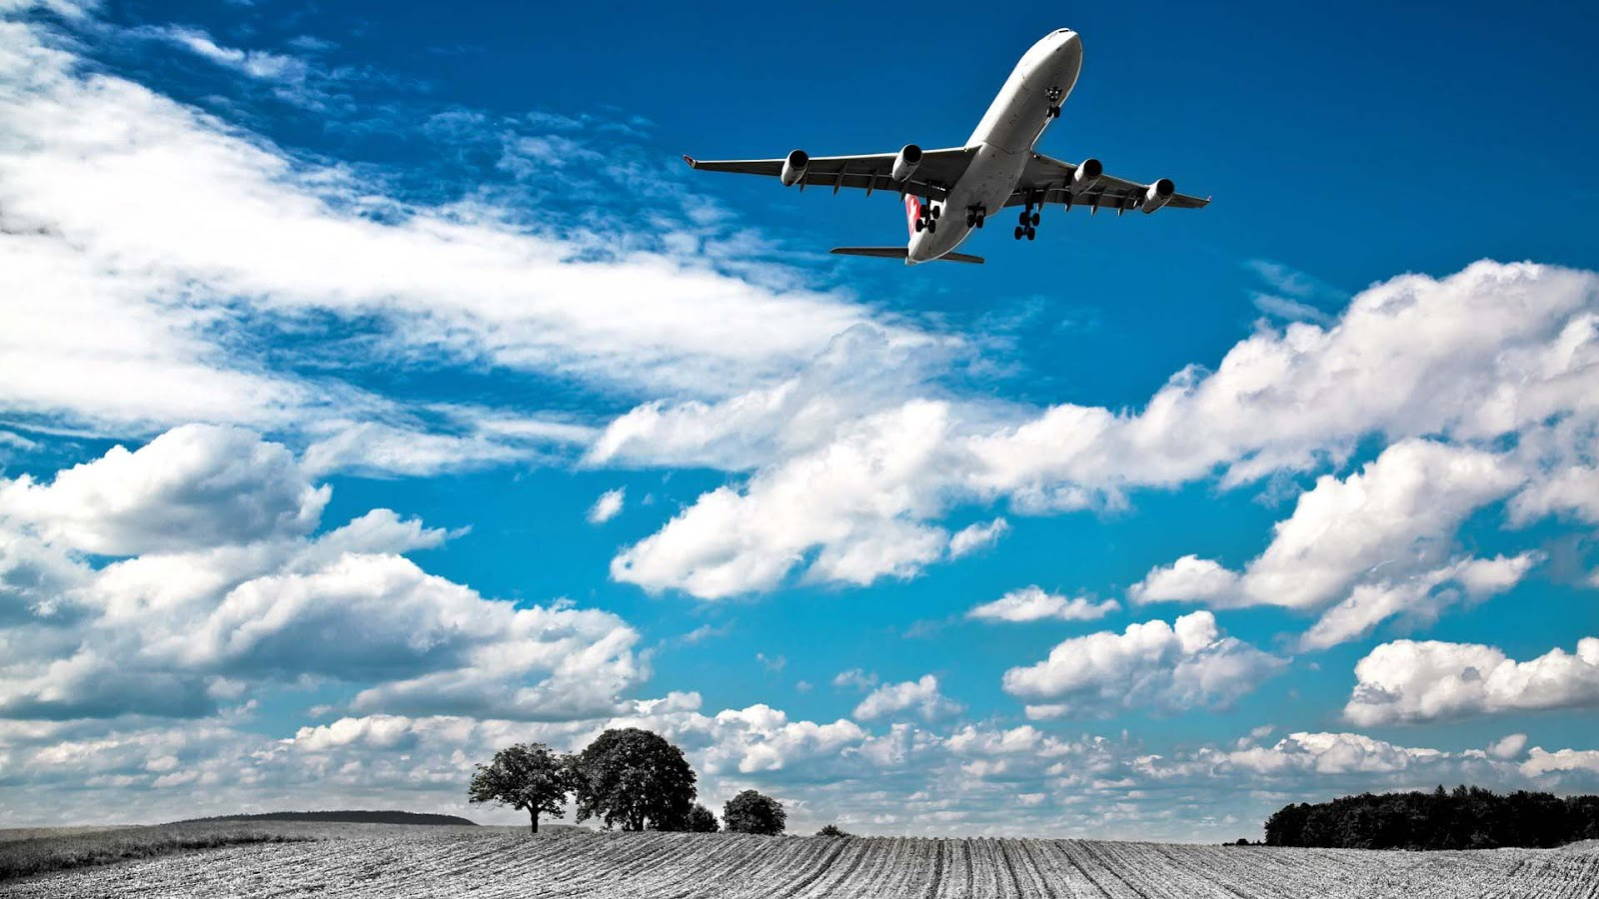

[This Photo](https://dulwlpaper.blogspot.com/2013/10/plane-images.html) by Unknown Author is licensed under [CC BY-NC-ND](https://creativecommons.org/licenses/by-nc-nd/3.0/)